BellPull Graphs

The BellPull output system is designed to provide three different types of output within a single graph area. These are :-

1. Force v time
2. Force v bell position
3. Force v time comparison.

The coding is contained within BellPull-Overlay-Gn.py which is still being developed. Controls are described below and the opening screen looks like this : -

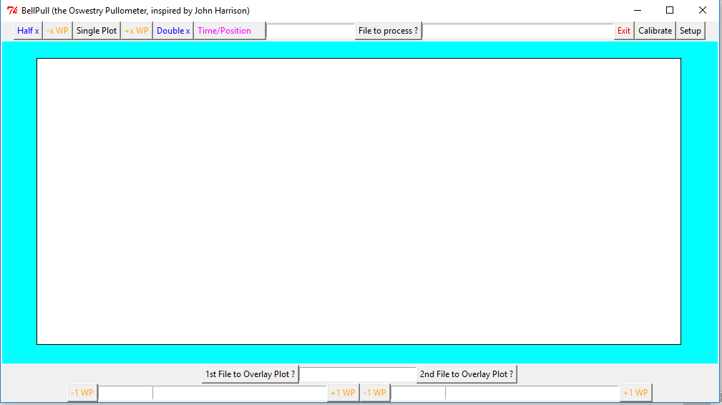

The top control bar looks after graphs types 1 and 2. The upper LH group of controls are used as follows



Clicking on “Single Plot” will bring up a file dialogue box allowing selection of the required file to plot I have made one called “Example1.csv” available for you to explore[1]. As soon as a file is selected it will be displayed as type 1. The text box will display “WP 1 T” indicating that the graph starts on the LH side with the first Whole Pull and the file name will be displayed in the next text box.

The plot always starts from Bottom Dead Centre (BDC) preceding a handstroke and then plots hand/back until the plot area is filled. There are a pair of controls with yellow text marked “-x WP” and “+x WP” which can be used to step forwards or backwards through the ringing record. At the outset the value of x is set a t 1. The step size can be changed using the blue Double and Half buttons (I don’t think you can step bellow 1). Should you step outside of recorded data then blank space will be plotted. Hand and Back strokes are identified by coloured backgrounds with a vertical white line indicating when the bell changes direction. A magenta strip is drawn at the top of the graph whenever the bell is between passing Top Dead Centre (TDC), this reveals when the bell is being rung “over balance”.

The “Time/Position” button switches horizontal axis back and forth between Time and Position (It would be sensible to redraw the plot each time this control is used but, at present, it waits until a plus or minus control is used). In the position mode all whole pulls are plotted with the selected one being highlighted. The plot starts from halfway along the horizontal axis with leftward movement towards handstroke TDC shown in red. As the bell motion reverses the plot turns blue and tracks right through BDC to backstroke TDC. Again, on reversal the plot turns back to red.

Type 3 plots (comparison) makes use of the lower set of controls.



This allows comparison of two whole pulls from two separate files (although using the same file is allowed). Since the timing of strokes will rarely be identical the horizontal scaling is adjusted so that each stroke (BDC to BDC) takes up half the plot area. Vertical lines are drawn between the strokes for each plot and the coincidence of these lines is an indicator of how well the time adjustment is working. Both graphs are plotted to a common force scale.

The required files are selected by clicking on the Overlay Plot buttons and each opens a dialogue box allowing file selection. The plot is not activated until two files have been specified. The respective file names appear in the two long text boxes with information about whole pulls in the smaller boxes.

The opening screen shows both whole pulls from the pull off stage so does not make much sense. Using the 4 yellow controls each part of the display can be stepped forwards or backwards. The first file is shown in blue with the time axis shown along the bottom. Reversal is indicated with an orange bar and any periods of over TDC ringing are indicated with a magenta stripe. The 2nd file is shown in green with time, reversal and over TDC shown at the top of the display. Differences between the two graphs are shown by shading in red or yellow.

**Additional features**

At the top of the chart is a control marked “File to Process”. This opens a dialogue box allowing selection of a raw data file which can then be processed to produce output for plotting. The stages of processing are displayed in the text box.

The Calibrate and Setup controls have not yet been implemented.

Richard Major

1st March 2018

1. This file is of John Harrison ringing Plain Bob Minor on the 6th. Due to my incompetence the recording cut out after a couple of leads. The system is designed to expect the bell to be set at the start and end of the file and, in this case, this did not happen. To allow file processing I had to find a point when the bell was near TDC, cut out the remaining data and splice in some false information with the bell set. As a result this file may not be strictly accurate but it demonstrates what can be viewed.